**Association Rules**

**Example- Books Data set**

**Based on Apriori algorithm with support 0.02 and confidence 0.5 and minimum length as 3 we are getting 190 rules.**

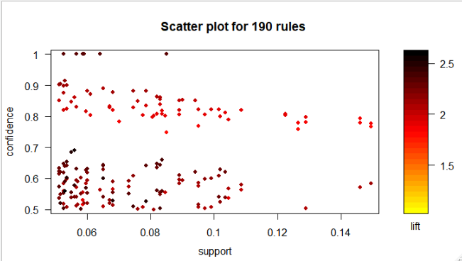

**inspect(head(sort(Brules, by = "lift")))**

lhs rhs support confidence lift count

[1] {ChildBks,YouthBks,DoItYBks} => {RefBks} 0.0530 0.5578947 2.600908 106

[2] {YouthBks,CookBks,ArtBks} => {GeogBks} 0.0560 0.6913580 2.504920 112

[3] {ChildBks,CookBks,DoItYBks,GeogBks} => {ArtBks} 0.0535 0.6011236 2.494289 107

[4] {CookBks,DoItYBks,GeogBks} => {ArtBks} 0.0650 0.5990783 2.485802 130

[5] {ChildBks,YouthBks,ArtBks} => {GeogBks} 0.0550 0.6832298 2.475470 110

[6] {ChildBks,YouthBks,CookBks} => {RefBks} 0.0680 0.5271318 2.457491 136

**> inspect(head(sort(Brules, by = "confidence")))**

lhs rhs support confidence lift count

[1] {YouthBks,ItalCook} => {CookBks} 0.0590 1 2.320186 118

[2] {ArtBks,ItalCook} => {CookBks} 0.0565 1 2.320186 113

[3] {DoItYBks,ItalCook} => {CookBks} 0.0585 1 2.320186 117

[4] {GeogBks,ItalCook} => {CookBks} 0.0640 1 2.320186 128

[5] {ChildBks,ItalCook} => {CookBks} 0.0850 1 2.320186 170

[6] {ChildBks,GeogBks,ItalCook} => {CookBks} 0.0525 1 2.320186 105

**> inspect(head(sort(Brules, by = "support")))**

lhs rhs support confidence lift count

[1] {ChildBks,GeogBks} => {CookBks} 0.1495 0.7666667 1.778809 299

[2] {CookBks,GeogBks} => {ChildBks} 0.1495 0.7766234 1.835989 299

[3] {ChildBks,CookBks} => {GeogBks} 0.1495 0.5839844 2.115885 299

[4] {ChildBks,DoItYBks} => {CookBks} 0.1460 0.7934783 1.841017 292

[5] {CookBks,DoItYBks} => {ChildBks} 0.1460 0.7786667 1.840820 292

[6] {ChildBks,CookBks} => {DoItYBks} 0.1460 0.5703125 2.022385 292

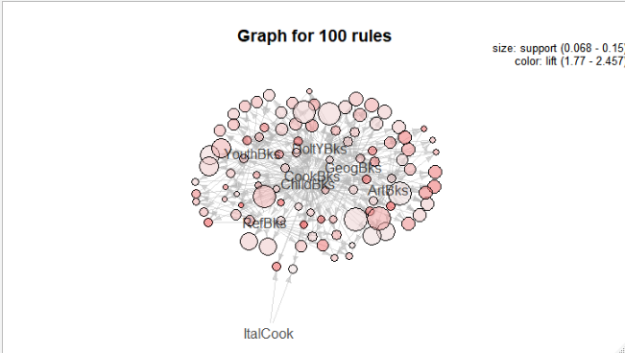

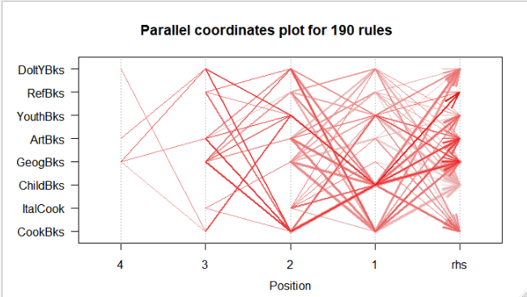

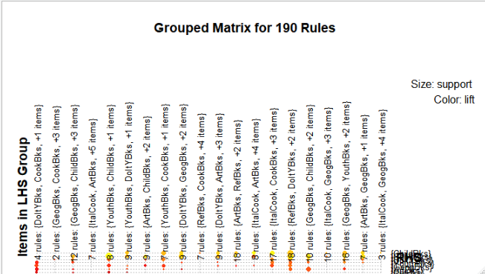

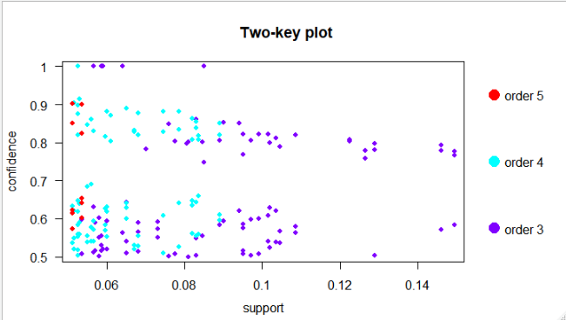

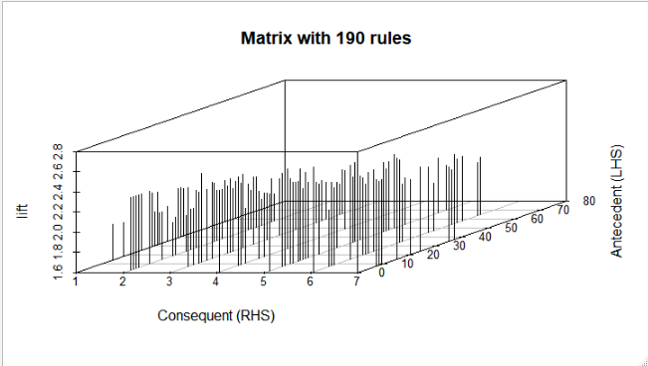

|  |
| --- |
| inspect(Youthrules[1:5])  lhs rhs support confidence lift count  [1] {YouthBks,ItalCook} => {CookBks} 0.059 1.0000000 2.320186 118  [2] {CookBks,ItalCook} => {YouthBks} 0.059 0.5198238 2.100298 118  [3] {YouthBks,RefBks} => {DoItYBks} 0.058 0.6010363 2.131334 116  [4] {DoItYBks,RefBks} => {YouthBks} 0.058 0.5497630 2.221265 116  [5] {YouthBks,DoItYBks} => {RefBks} 0.058 0.5021645 2.341093 116 |
|  |
| |  | | --- | | **Along with YouthBks, people are buying cookBks and RefBks as well.** | |